Riley Snowe

CS 499

Southern New Hampshire University

22 May 2022

Journal

The only artifact I have started work on is the first artifact. The first artifact comes from my CS 405 Secure Coding class regarding SQL injection. The assignment was from our second week in the class where we had to write code that prevented SQL injection. I have already implemented changes to the code, which was not a huge change.

Reviewing the code and what else could be changed, I found that my current code is very efficient in terms of operation and detection. The only additional security would come outside of this assignment in relation to the application’s database itself.

The changes made are renaming the variables to make more sense with what they are for, along with changes to the comments to be more in-depth. All initial artifacts, along with the changes to artifact one has been uploaded to GitHub.

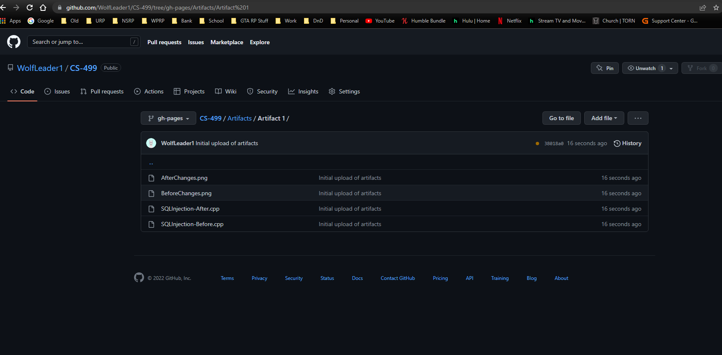

Before Changes:

After Changes:

